Vision and Scope Document

for

OJT Management System

Version 1.0 approved

Prepared by Dat Nguyen Phat

Process Impact

June 22, 2022

Table of Contents

Table of Contents ii

Revision History ii

1. Business Requirements 1

1.1. Background 1

1.2. Business Opportunity 1

1.3. Business Objectives 1

1.4. Success Metrics 1

1.5. Vision Statement 1

1.6. Business Risks 2

1.7. Business Assumptions and Dependencies 2

2. Scope and Limitations 2

2.1. Major Features 2

2.2. Scope of Initial and Subsequent Releases 3

2.3. Limitations and Exclusions 3

3. Business Context 4

3.1. Stakeholder Profiles 4

3.2. Project Priorities 5

3.3. Deployment Considerations 5

Revision History

|  |  |  |  |
| --- | --- | --- | --- |
| **Name** | **Date** | **Reason For Changes** | **Version** |
|  |  |  |  |
|  |  |  |  |

# Business Requirements

## Background

The process of applying for OJT and receiving and reviewing applications from OJT students at FPT University is quite laborious and traditional. Students up to the sixth semester will currently register for firms and internship opportunities by submitting their CVs and cover letters via the university's registration form, which will be delivered to the university's management system. The business relations department's personnel will next summarize the applications, download the essential papers to the computer, and manually approve them, which takes a long time due to the time it takes to modify forms and excel. The list of students who have signed up for OJT will be saved in a generic file and then divided into different files based on their majors. To check a student's profile, the officer must first download the student's profile (in pdf, docx, etc.) and then open it to check job details, business, cooperation terms, and so on. Every time a change occurs, such as a student wanting to save or change a business, it must be handled in a very sophisticated manner, devoting a significant amount of time and effort away from other critical tasks. Because the data is stored in an excel file, the synthesis and visualization of complete data is limited. Each time a student has to edit something, he must manually open the student's profile file. his traditional approach not only results in poor work performance, but it also has an impact on the assessment and acknowledgment of students' OJT, resulting in a strained relationship between schools and businesses.

## Business Opportunity

## Business Objectives

## Success Metrics

## Vision Statement

## Business Risks

## Business Assumptions and Dependencies

# Scope and Limitations

## Major Features

FE-1: View job list with its detail.

FE-2: View company list with associated jobs.

FE-3: Bookmark a favorite job.

FE-4: Create, view, modify student profile include CV, cover letter.

FE-5: Find, view necessary information for OJT term.

FE-6: Sign up for on-the-job training.

FE-7: View, write feedback for a job or a company.

FE-8: View, archive, and export to pdf/xslx the student’s OJT progress/term evaluation.

FE-9: Request to transfer the company.

FE-10: Request for reservation of OJT term.

FE-11: View, post, edit, deactivate (remove) a job.

FE-12: View list of OJT registration.

FE-13: Approve a OJT registration.

FE-14: View company’s student list.

FE-15: Send email/announcement to student.

FE-16: Add, view, modify a student’s evaluation.

FE-17: View, modify company’s profile.

FE-18: View list of cooperative company.

FE-19: Add, view, modify, activate/deactivate a cooperative company.

FE-20: View statistic, export student list to pdf/xslx.

FE-21: View, approve/decline a OJT registration form.

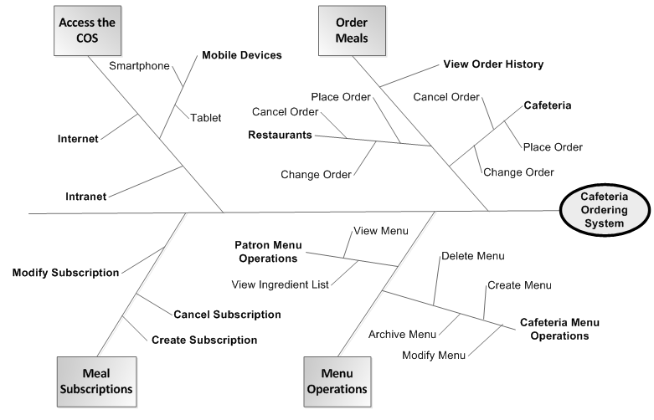

Figure 1. Partial feature tree for the Cafeteria Ordering System.

## Scope of Initial and Subsequent Releases

|  |  |  |  |
| --- | --- | --- | --- |
| Feature | Release 1 | Release 2 | Release 3 |
| FE-1: View job list with its detail. | View job list with brief information of each job, search for a job, filter by job majors | Filter and sort the job list by rating, allowance | Filter and sort the job list by location |
| FE-2: View company list with associated jobs. | View company list with associated jobs | Display best recommended jobs of a company | Sort company of different majors by rating |
| FE-3: Bookmark a favorite job. | Not implemented | Toggle a favorite job and view favorite job list | Fully implemented |
| FE-4: Create, view, modify student profile include CV, cover letter. | Create student profile, upload resume/CV, cover letter as pdf/docx file, review and modify profile | Create and modify resume/CV, cover letter online, export to pdf/docx | Fully implemented |
| FE-5: Find, view necessary information for OJT term. | View information, term/condition/regulation, announcement for OJT term | Write sharing about OJT experience | Fully implemented |
| FE-6: Sign up for on-the-job training. | Fill the OJT registration form | Request for change in registration form | Fully implemented |
| FE-7: View, write feedback for a job or a company. | View feedback/review of a job, a company, write review of a job/company after OJT | Rate a job/company | Give useful or not useful opinion for feedbacks. |
| FE-8: View, export to pdf/xslx the student’s OJT progress/term evaluation. | View detail student OJT term’s evaluation | Export evaluation detail to pdf/xslx | Feedback about OJT evaluation |
| FE-9: Request to transfer the company. | Send transfer company request to Corporate Relations' Department, get response on the system. | Get response through email/message | Fully implemented |
| FE-10: Request for reservation of OJT term. | Send reservation request to Corporate Relations' Department, get response on the system | Get response through email/message | Fully implemented |
| FE-11: View, post, edit, deactivate (remove) a job | Post, view and edit a job’s detail | Deactivate/Hide/Remove a job on list | Fully implemented |
| FE-12: View list of OJT registration. | View list of all student’s OJT registration | Filter registration by job majors | General statistic of registration |
| FE-13: Approve a OJT registration. | View detail registration form, approve/decline | Leave feedback for declined registration form | Fully implemented |
| FE-14: View company’s student list. | View list of current boarding student, search a student, filter by majors | View general statistic of student list | Fully implemented |
| FE-15: Send email/announcement to student. | Not implemented | Post announcement on the system | Send mail to response student’s request |
| FE-16: Add, view, modify a student’s evaluation. | Add progress/term evaluation for students | Review, modify evaluation | General statistic of student’s evaluation |
| FE-17: View, modify company’s profile. | Not implemented | Add, view, modify company’s profile | Fully implemented |
| FE-18: View list of cooperative company. | View cooperative company list, search for a company | Filter company list by majors, rating, location,… | Fully implemented |
| FE-19: Add, view, modify, activate/deactivate a cooperative company. | Add new cooperative company, view company’s detail | Activate/Deactivate a company on the system | Fully implemented |
| FE-20: View statistic, export student list to pdf/xslx. | Not implemented | View general statistics of student on the system (OJT status, evaluation, request, etc) | Export student list to .xslx file |
| FE-21: View, approve/decline a OJT registration form. | View students’ OJT registration form, approve/decline | Leave feedback on registration form | Fully implemented |

## Limitations and Exclusions

LI-1: Company which Students who want to change companies are only processed for the first four weeks.

LI-2: Companies proposed by students that do not have a cooperation agreement with the university will not be able to post job information

LI-3: The OJT management system may be suitable for operating model of student, Corporate’s Relationship Department at FPT University HCMC.

# Business Context

## Stakeholder Profiles

|  |  |  |  |  |
| --- | --- | --- | --- | --- |
| Stakeholder | Major Value | Attitudes | Major Interests | Constraints |
| Corporate Management | Improved employee productivity; cost savings for cafeteria | Strong commitment through release 2; support for release 3 contingent on earlier results | Cost and employee time savings must exceed development and usage costs | None identified |
| Cafeteria Staff | More efficient use of staff time throughout the day; higher customer satisfaction | Concern about union relationships and possible downsizing; otherwise receptive | Job preservation | Training for staff in Internet usage needed; delivery staff and vehicles needed |
| Patrons | Better food selection; time savings; convenience | Strong enthusiasm, but might not use it as much as expected because of social value of eating lunches in cafeteria and restaurants | Simplicity of use; reliability of delivery; availability of food choices | Corporate intranet access, Internet access, or a mobile device is needed |
| Payroll  Department | No benefit; needs to set up payroll deduction registration scheme | Not happy about the software work needed, but recognizes the value to the company and employees | Minimal changes in current payroll applications | No resources yet committed to make software changes |
| Restaurant Managers | Increased sales; marketing exposure to generate new customers | Receptive but cautious | Minimal new technology needed; concern about resources and costs of delivering meals | Might not have staff and capacity to handle order levels; might not have all menus online |

## Project Priorities

|  |  |  |  |
| --- | --- | --- | --- |
| Dimension | Constraint | Driver | Degree of Freedom |
| Features | All features scheduled for release 1.0 must be fully operational |  |  |
| Quality | 95% of user acceptance tests must pass; all security tests must pass |  |  |
| Schedule |  |  | release 1 planned to be available by end of Q1 of next year, release 2 by end of Q2; overrun of up to 2 weeks acceptable without sponsor review |
| Cost |  |  | budget overrun up to 15% accept able without sponsor review |
| Staff |  | team size is half-time project manager, half-time BA, 3 developers, and 1 tester; additional developer and half-time tester available if necessary |  |

## Deployment Considerations

The web server software will need to be upgraded to the latest version. Apps will have to be developed for iOS and Android smartphones and tablets as part of the second release, with corresponding apps for Windows Phone and tablets to follow for the third release. Any corresponding infrastructure changes must be in place at the time of the second release. Videos no more than five minutes in length shall be developed to train users in both the Internet-based and app-based versions of COS.